NOTICE OF HEARING

PUBLIC LANDS APPEAL BOARD
Knelsen Sand and Gravel Ltd.
Refusal of Application for Surface Material Exploration SME 210063
Our File No. PLAB 22-0019
Description

The Public Lands Appeal Board has scheduled a hearing of this appeal by written submissions commencing on July 14, 2023 with respect to the March 3, 2023, decision of the Director, Forestry and Parks, to refuse an application by Knelsen Sand and Gravel Ltd. for Surface Material Exploration SME 210063 located at N½ 16, SW 16, E½ 17, S½ 21, Twp 104, Rge 19, W5M.
The issues to be heard in this appeal are:

- Did the Director, in deciding to refuse the Appellant’s application for SME 210063, err in the determination of a material fact on the face of the record?

- Did the Director, in deciding to refuse the Appellant’s application for SME 210063, err in law?

- Did the Director, in deciding to refuse the Appellant’s application for SME 210063, exceed the Director’s or Officer’s jurisdiction or legal authority?

- The decision is expressly subject to appeal under Section 15 of the Public Lands Administration Regulation or Section 59.2(3) of the Public Lands Act (this is for appealing a deemed rejection because of the failure of a Director or Officer to approve or refuse an application for a disposition, authorization, or approval within a 30 day time limit unless an extension was approved).

- The weight, if any, to be given to the written submissions of Unity Sand and Gravel outlining their position regarding the appeal.

You may request a copy of the written hearing submissions by contacting the Board.

Information Requests  Please contact the Public Lands Appeal Board for further information regarding the file in this matter.  Public Lands Appeal Board  #306, Peace Hills Trust Tower  10011 – 109 Street  Edmonton, Alberta T5J 3S8  E-Mail: PLAB@gov.ab.ca  Phone: 780-427-6207  Fax: 780-427-4693 | 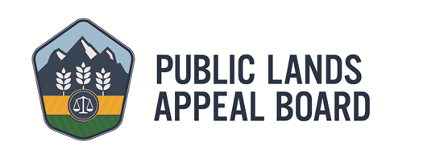
Posted: June 30, 2023

